USING CONTACT PERSON ADDRESS ON SALE INVOICE REPORT

STEP 1:

create partner

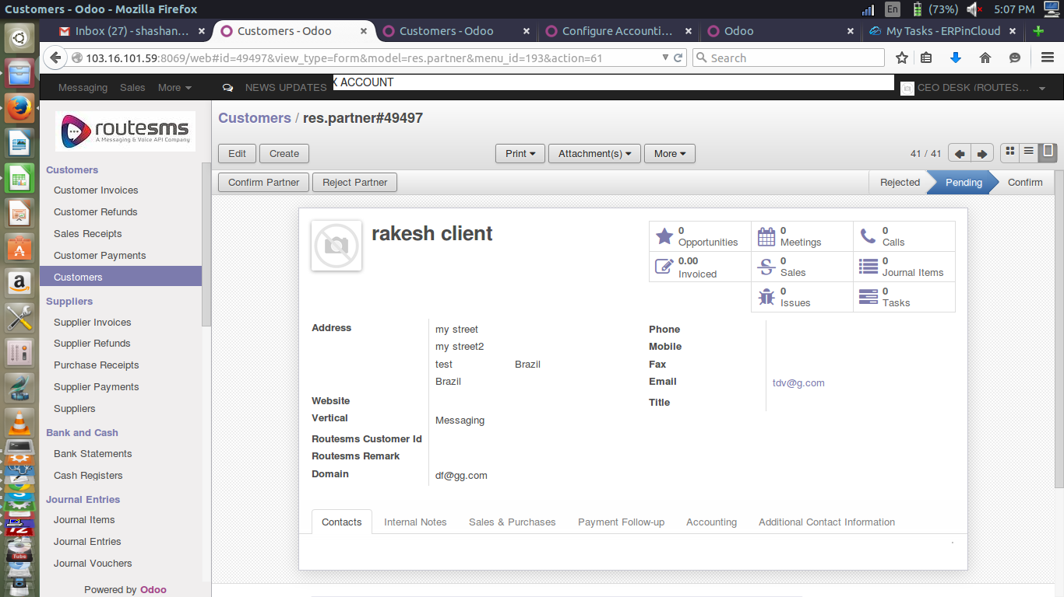

STEP 2: create contact person

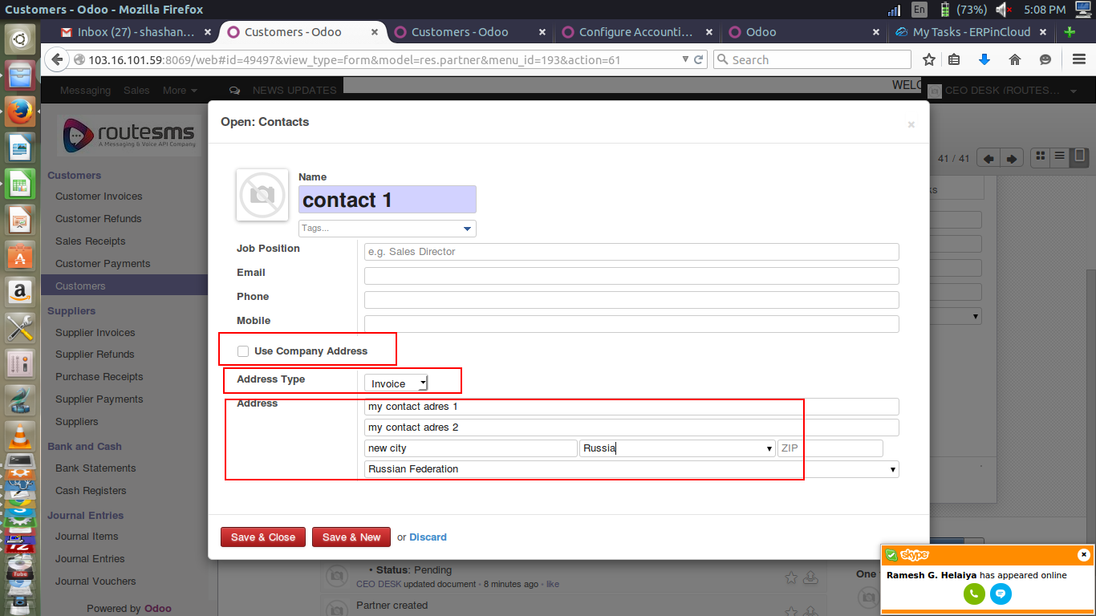

STEP 3: create another contact person(optional)

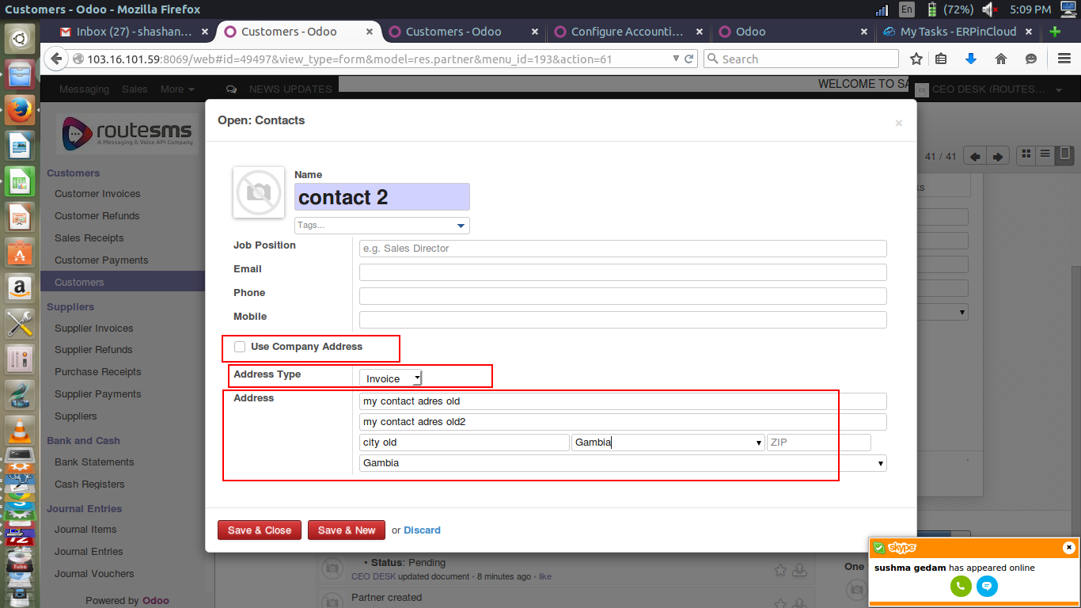

STEP 4: generate odoo id

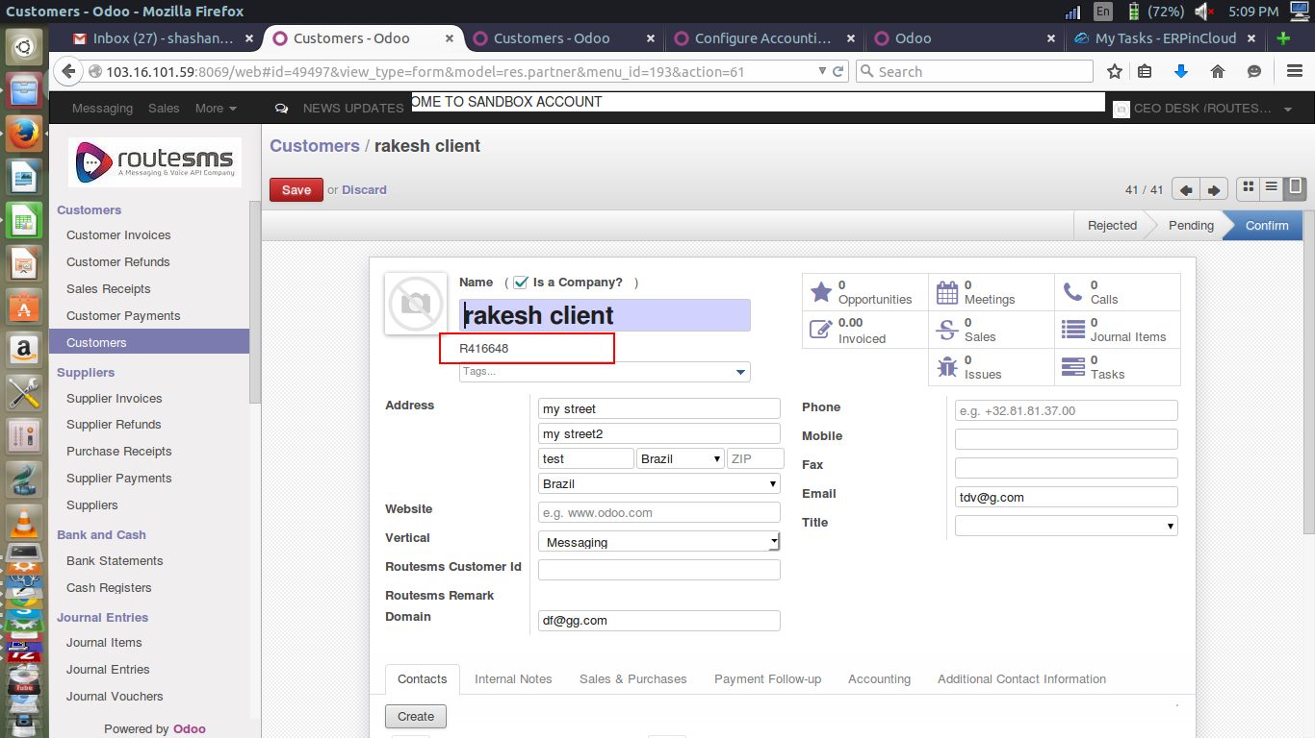

STEP 5:
create sale invoice and mark the configuration for using contact person address

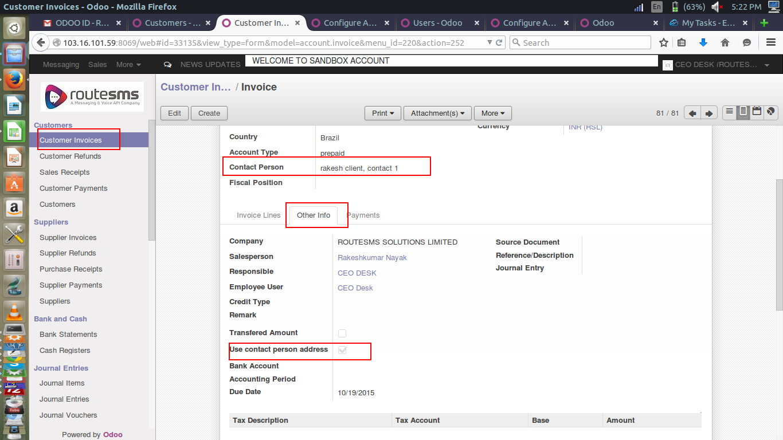

STEP 6: print report

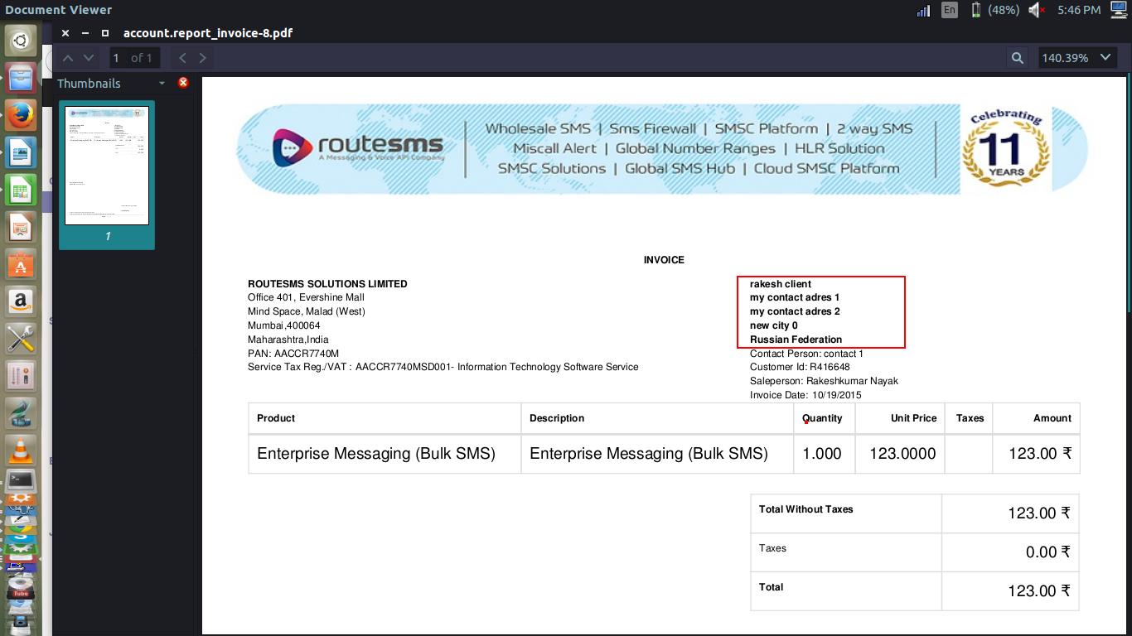

THANK YOU

